Kubernetes Task-06
- Create a ConfigMap from a directory containing multiple files and inject the variables into a pod as environment variables.

Step 1. Create a directory
mkdir config-files

Step 2. Create the first file
echo "sabair" > config-files/name

Step 3. Create the second file
echo "Hyderabad" > config-files/city

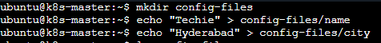
Check the files:
ls config-files
You should see:
city
name

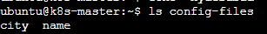
Check their contents:
cat config-files/name
cat config-files/city

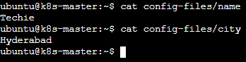

Step 4. Create ConfigMap from the directory
kubectl create configmap app-config --from-file=config-files/
Verify:
kubectl get configmap app-config
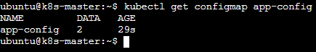
To see the contents:
kubectl describe configmap app-config
You should see:
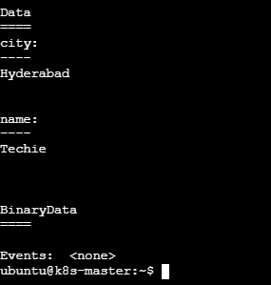

Step 5. Create a Pod and inject the ConfigMap as environment variables
Create the YAML:
vi configmap-pod.yaml and add
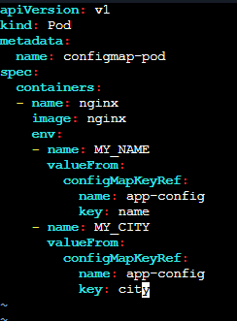
Save and exit.

Step 6. Create the Pod
kubectl apply -f configmap-pod.yaml

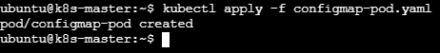
Check:
kubectl get pod configmap-pod
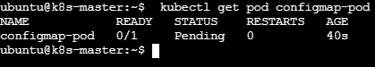
Wait until it shows:
Running
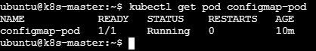

Step 7. Verify the environment variables
Run:
kubectl exec configmap-pod -- env | grep -E 'MY_NAME|MY_CITY'
Expected:
MY_NAME=sabair
MY_CITY=Hyderabad
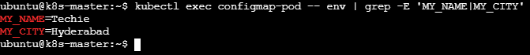

2. Create a ConfigMap from a file and mount it as a volume inside a pod, ensuring the configuration data is available as files.

Step 1. Create a configuration file
echo "This is my application configuration" > app.conf
Verify:
cat app.conf
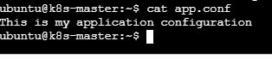

Step 2. Create a ConfigMap from the file
kubectl create configmap app-config-file --from-file=app.conf
Verify:
kubectl get configmap app-config-file
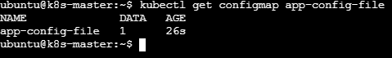
Check the contents:
kubectl describe configmap app-config-file
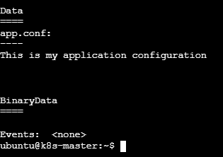

Step 3. Create the Pod YAML
vi config-volume-pod.yaml and add
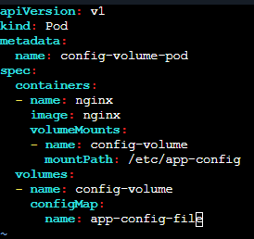

Save and exit.

Step 4. Create the Pod
kubectl apply -f config-volume-pod.yaml
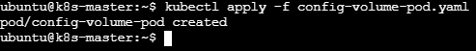
Check:
kubectl get pod config-volume-pod
Wait until it shows:
Running
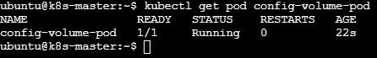

Step 5. Verify the configuration file inside the Pod
kubectl exec config-volume-pod -- ls /etc/app-config
Expected:
app.conf
Now read the file:
kubectl exec config-volume-pod -- cat /etc/app-config/app.conf
Expected:
This is my application configuration

3. Create a Secret with sensitive information (username and password) and inject it into a pod as environment variables.

Step 1. Create the Secret
You can create it directly with kubectl:
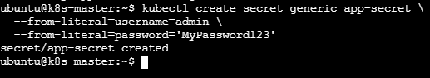

Step 2. Verify the Secret
kubectl get secret app-secret
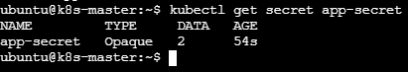
For a real application, we shouldn’t put passwords directly in shell history or YAML files. This is fine for a Kubernetes lab.
To check its keys:
kubectl describe secret app-secret

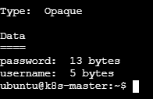
The actual values are not displayed by describe.

Step 3. Create the Pod YAML
vi secret-pod.yaml and add
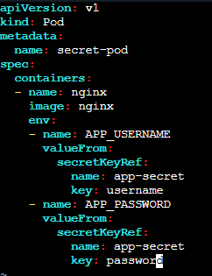

Save and exit.

Step 4. Create the Pod
kubectl apply -f secret-pod.yaml
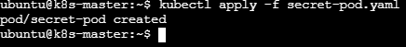
Check:
kubectl get pod secret-pod
Wait until:
NAME READY STATUS
secret-pod 1/1 Running
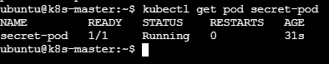

Step 5. Verify the environment variables
kubectl exec secret-pod -- env | grep -E 'APP_USERNAME|APP_PASSWORD'
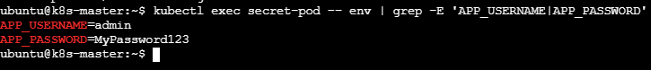

4. Create a Secret using a YAML file, mount it as a volume in a pod, and verify the specific Secret values are available as files.

Step 1. Create the Secret YAML
vi secret-volume.yaml and add
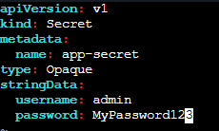

Save and exit.

Step 2. Create the Secret
kubectl apply -f secret-volume.yaml

Verify:
kubectl get secret app-secret
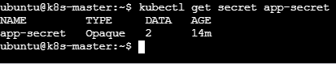
You can check the keys:
kubectl describe secret app-secret
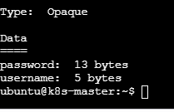

Step 3. Create the Pod YAML
vi secret-volume-pod.yaml and add
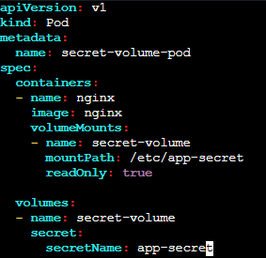

Save and exit.

Step 4. Create the Pod
kubectl apply -f secret-volume-pod.yaml
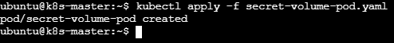
Check:
kubectl get pod secret-volume-pod
Wait for:
NAME READY STATUS
secret-volume-pod 1/1 Running

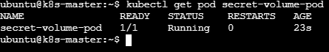

Step 5. Verify the Secret files
List the files:
kubectl exec secret-volume-pod -- ls -l /etc/app-secret
Expected:
password
username

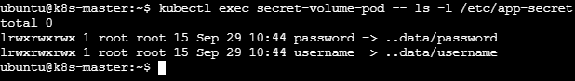

Step 6. Read the username
kubectl exec secret-volume-pod -- cat /etc/app-secret/username
Expected:
Admin

Step 7. Read the password
kubectl exec secret-volume-pod -- cat /etc/app-secret/password
Expected:
MyPassword123

5. Inject a ConfigMap as environment variables and a Secret as files into the same pod, ensuring both are accessible within the pod.
Step 1. Create the ConfigMap

Step 2. Create the Secret YAML
vi app-secret.yaml and add

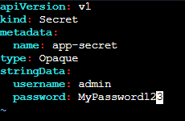

Save and exit.
Apply:
kubectl apply -f app-secret.yaml

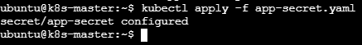
Verify:
kubectl get secret app-secret
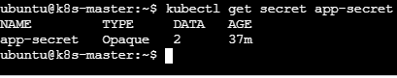

3. Create the Pod
vi config-secret-pod.yaml and add

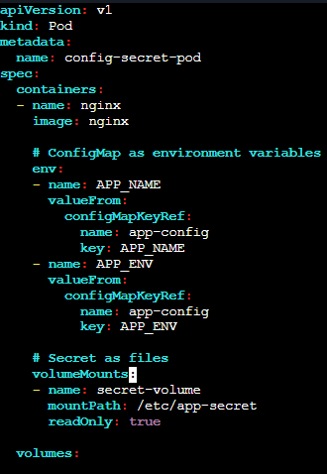

Save and exit.

Step 4. Create the Pod
kubectl apply -f config-secret-pod.yaml
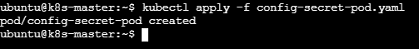
Check:
kubectl get pod config-secret-pod
You should get:
NAME READY STATUS
config-secret-pod 1/1 Running
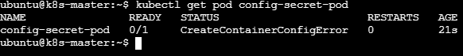

Step 5. Verify ConfigMap environment variables
kubectl exec config-secret-pod -- env | grep -E 'APP_NAME|APP_ENV'
Expected:
APP_NAME=myapp
APP_ENV=production

Step 6. Verify Secret files
List the mounted files:
kubectl exec config-secret-pod -- ls /etc/app-secret
Expected:
password
username
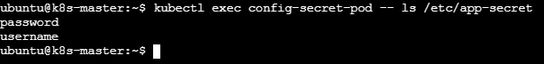
Check username:
kubectl exec config-secret-pod -- cat /etc/app-secret/username
Expected: Admin
Check password: kubectl exec config-secret-pod -- cat /etc/app-secret/password
Expected: MyPassword123

